1. Visualize the distribution of chlorophyll a and chlorophyll b values using histogram or density plots in Deciduous forests.

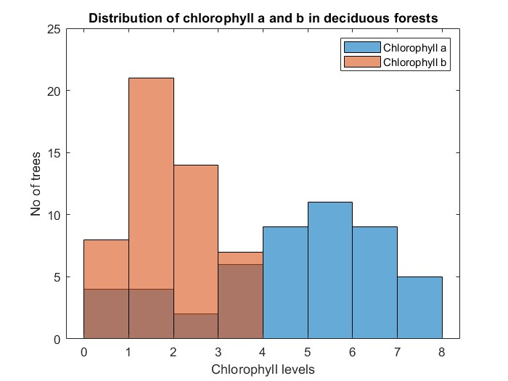

**Chlorophyll a** shows a left-skewed uniform distribution whereas **chlorophyll b** has a pretty centered uniform distribution

2. Visualize the distribution of chlorophyll a and chlorophyll b values using histogram or density plots in Evergreen forests.

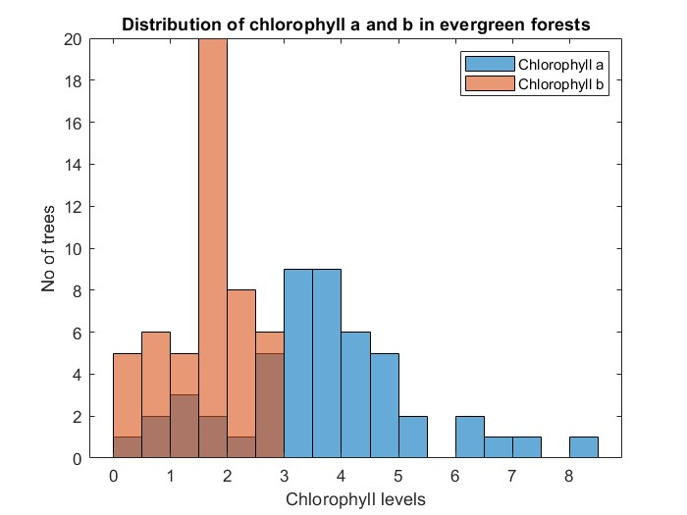

**Chlorophyll a** shows a right-skewed uniform distribution whereas **chlorophyll b** has a pretty centered uniform distribution.

3. Visualize the distribution of chlorophyll a and chlorophyll b values using histogram or density plots without separating the measurements from each forests.

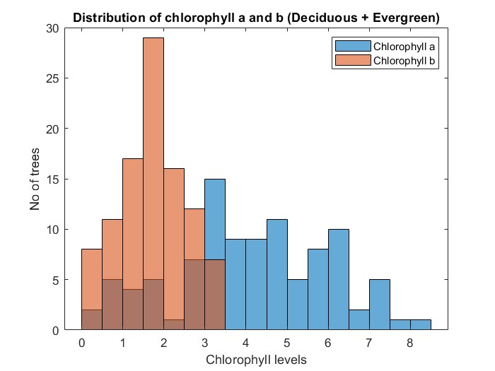

Both of the chlorophyll samples show a centered uniform distribution.

4. Plot 1, 2, and 3 in the same plot together and explore how it changes.

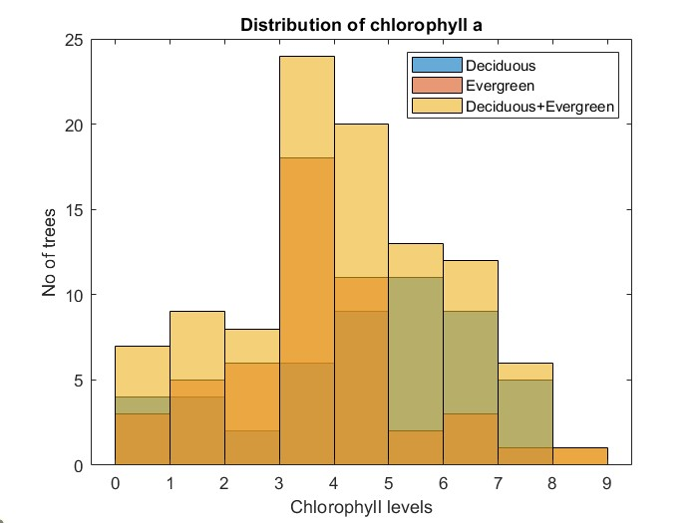 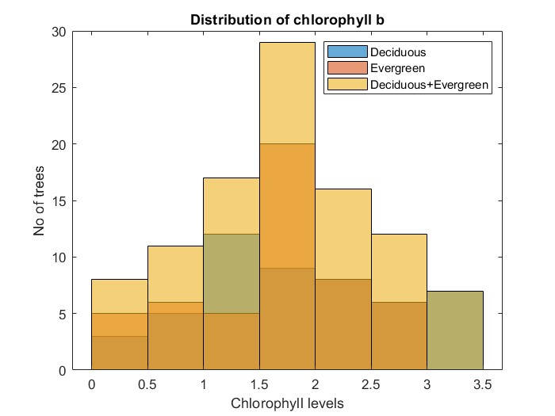

Analysing the histograms we can see that the individually plotted deciduous and evergreen samples for **Chlorophyll a** are uniform distributions skewed to the left and right respectively. When they are taken as one combined sample the distribution is a roughly centred uniform distribution.

Similarly, for **Chlorophyll b** all of them appear to be centered uniform distributions.

5. Calculate summary statistics (mean, median, mode and standard deviation) of chlorophyll a and chlorophyll b measurements from Deciduous forests separately, Evergreen forests separately and both the forests together.

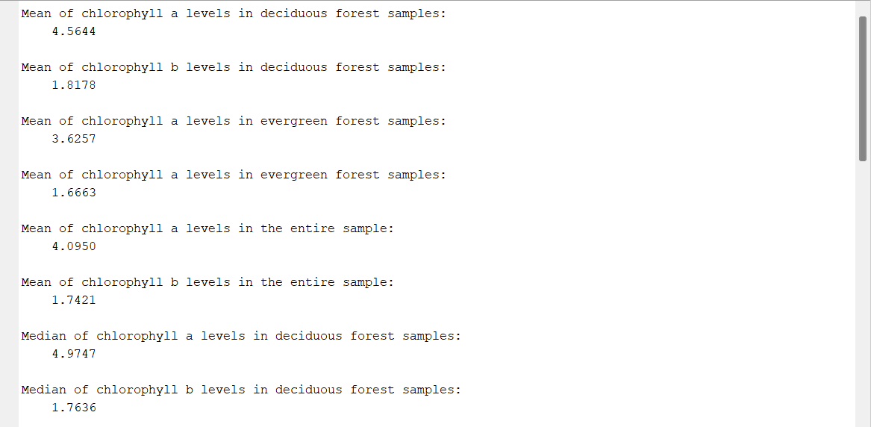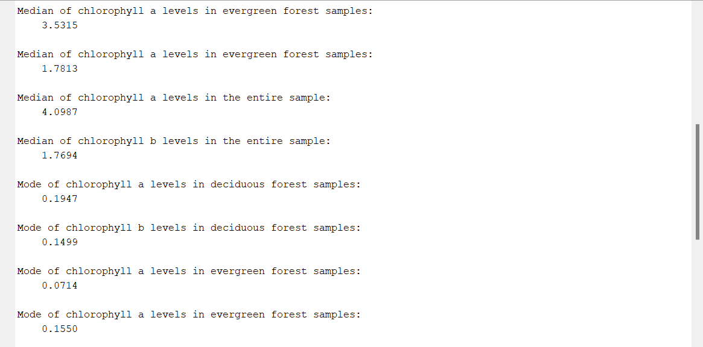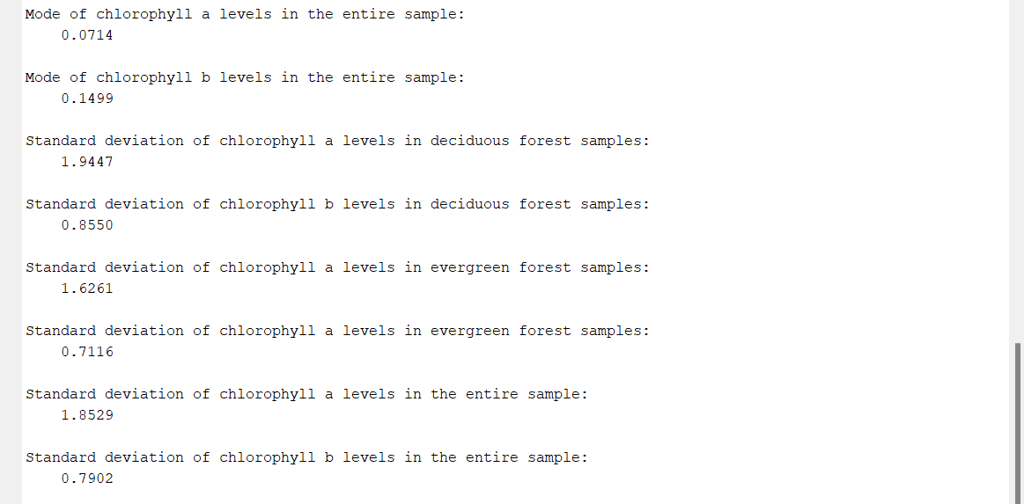

6. In the same boxplot, compare how the distribution of chlorophyll a and chlorophyll b values compare in Deciduous forests and Evergreen forests

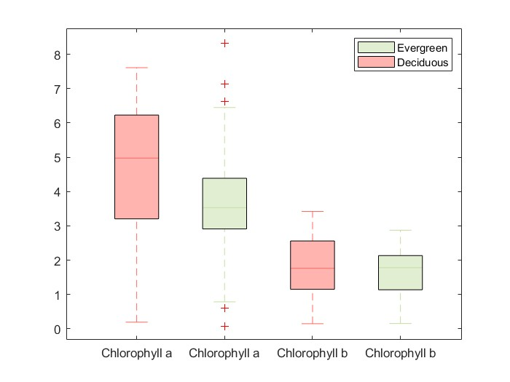

**Chlorophyll a:**

Deciduous forest: 25th %ile = 3.20454 median=4.9747 a75th %ile=6.722761  
 Evergreen forest: 25th %ile = 2.91088 median=3.5315 a75th %ile=4.38797

**Chlorophyll b:**

Deciduous forest: 25th %ile = 1.15059 median=1.7636 a75th %ile=2.56148  
 Evergreen forest: 25th %ile = 1.13786 median=1.7813 a75th %ile=2.13301

7. Are the variances between chlorophyll a and chlorophyll b measurements differ significantly? Perform appropriate statistical tests to support your claim. Compare variances of chlorophyll content from Deciduous forests separately, Evergreen forests separately and both the forests together.

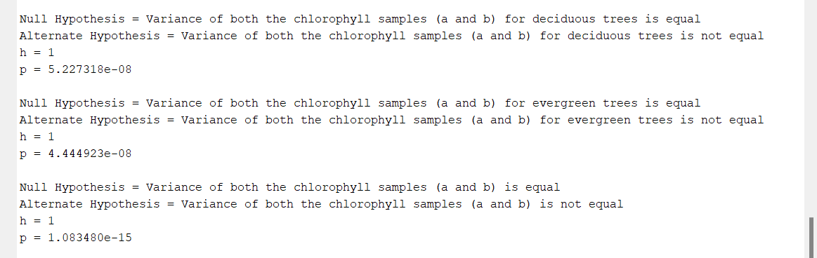

Using the f-test analysis to check whether the variances of the given samples are equal or not.  
Significance criteria, α = 0.05 (Default)

As the function returns a **h value** of 1 for all three cases, we can safely reject the null hypothesis for all of them. Therefore, neither of the samples have an equal population variance

8. Finally, test whether the mean of chlorophyll a is greater than mean of chlorophyll b using appropriate statistical test in all three combinations: Deciduous forests separately, Evergreen forests separately and both the forests together. Clearly state your null hypothesis, chosen significance criteria and the result of hypothesis testing.

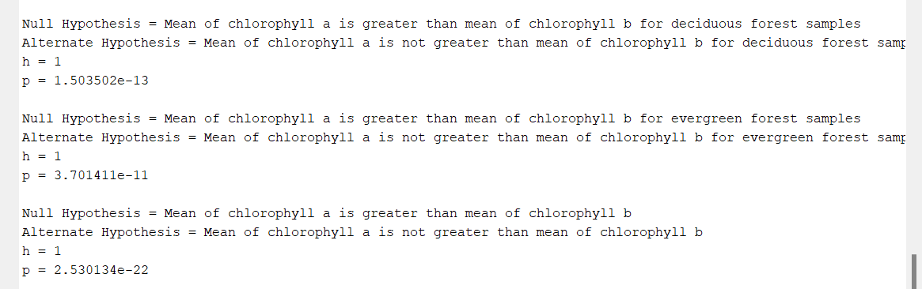

Using the separate t-test analysis to check whether the population mean of ‘chlorophyll a’ in the given sample is greater than ‘chlorophyll b’.  
Significance criteria, α = 0.05 (Default)

As the function returns a **h value** of 1 for all three cases, we can safely reject the null hypothesis for all of them. Therefore, the population mean of ‘chlorophyll a’ values is not greater than ‘chlorophyll b’ in any of the given samples.

**Code**

The link for the code and all the images used can be found here: <https://drive.google.com/drive/folders/19UIi92eD5XKcX0EjL5y5fkqHave_vGqC?usp=sharing>

**The End**